|  |  |
| --- | --- |
| **Ex. No. 1** | **Design a Web Page using HTML** |
| **Date of Exercise** | 12-12-2022 |

**Aim**

Create a HTML web page for your Personal Profile that conforms to HTML Features

**Description**

|  |  |
| --- | --- |
| [<!DOCTYPE>](https://www.w3schools.com/TAGS/tag_doctype.asp) | Defines the document type |
| [<html>](https://www.w3schools.com/TAGS/tag_html.asp) | Defines an HTML document |
| [<head>](https://www.w3schools.com/TAGS/tag_head.asp) | Contains metadata/information for the document |
| [<title>](https://www.w3schools.com/TAGS/tag_title.asp) | Defines a title for the document |
| [<body>](https://www.w3schools.com/TAGS/tag_body.asp) | Defines the document's body |
| [<h1> to <h6>](https://www.w3schools.com/TAGS/tag_hn.asp) | Defines HTML headings |
| [<p>](https://www.w3schools.com/TAGS/tag_p.asp) | Defines a paragraph |
| [<br>](https://www.w3schools.com/TAGS/tag_br.asp) | Inserts a single line break |
| [<hr>](https://www.w3schools.com/TAGS/tag_hr.asp) | Defines a thematic change in the content |
| [<!--...-->](https://www.w3schools.com/TAGS/tag_comment.asp) | Defines a comment |
| [<ul>](https://www.w3schools.com/TAGS/tag_ul.asp) | Defines an unordered list |
| [<ol>](https://www.w3schools.com/TAGS/tag_ol.asp) | Defines an ordered list |
| [<li>](https://www.w3schools.com/TAGS/tag_li.asp) | Defines a list item |
| [<dl>](https://www.w3schools.com/TAGS/tag_dl.asp) | Defines a description list |
| [<dt>](https://www.w3schools.com/TAGS/tag_dt.asp) | Defines a term/name in a description list |
| [<dd>](https://www.w3schools.com/TAGS/tag_dd.asp) | Defines a description of a term/name in a description list |
| [<table>](https://www.w3schools.com/TAGS/tag_table.asp) | Defines a table |
| [<caption>](https://www.w3schools.com/TAGS/tag_caption.asp) | Defines a table caption |
| [<th>](https://www.w3schools.com/TAGS/tag_th.asp) | Defines a header cell in a table |
| [<tr>](https://www.w3schools.com/TAGS/tag_tr.asp) | Defines a row in a table |
| [<td>](https://www.w3schools.com/TAGS/tag_td.asp) | Defines a cell in a table |
| [<thead>](https://www.w3schools.com/TAGS/tag_thead.asp) | Groups the header content in a table |
| [<tbody>](https://www.w3schools.com/TAGS/tag_tbody.asp) | Groups the body content in a table |
| [<tfoot>](https://www.w3schools.com/TAGS/tag_tfoot.asp) | Groups the footer content in a table |
| [<col>](https://www.w3schools.com/TAGS/tag_col.asp) | Specifies column properties for each column within a <colgroup> element |
| [<colgroup>](https://www.w3schools.com/TAGS/tag_colgroup.asp) | Specifies a group of one or more columns in a table for formatting |

**Pr<!DOCTYPE html>**

**<html>**

**<head>**

**</head>**

**<body>**

**<center>**

**<h1>MY RESUME PAGE</h1>**

**</center>**

**<div>**

**<table>**

**<tr>**

**<td style="padding-left: 200px;">**

**<h3>PERSONAL INFO</h3>**

**Dhanush K B<br>**

**369/9<br>**

**New sakthi nagar<br>**

**Cak road<br>**

**Karur-639114<br>**

**ph-<a href="tel:9025321821">9025321821</a>**

**</td>**

**<td style="padding-left: 600px;" rowspan="7">**

**<center>**

**<img src="images.png" width="120%">**

**</center>**

**</td>**

**</tr>**

**</table>**

**</div>**

**<hr>**

**<div style="padding-left: 200px;align-items: center;display: flex;">**

**<a href="https://www.w3schools.com/html/tryit.asp?filename=tryhtml_table_cellpadding2" style="text-decoration: none;">My web page</a>&nbsp;&nbsp;&nbsp;&nbsp;&nbsp;&nbsp;&nbsp;&nbsp;&nbsp;&nbsp;&nbsp;&nbsp;&nbsp;&nbsp;&nbsp;&nbsp;&nbsp;&nbsp;&nbsp;&nbsp;**

**<a href="https://online.karunya.edu/oauth/login" style="text-decoration: none;">My college</a>&nbsp;&nbsp;&nbsp;&nbsp;&nbsp;&nbsp;&nbsp;&nbsp;&nbsp;&nbsp;&nbsp;&nbsp;&nbsp;&nbsp;&nbsp;&nbsp;&nbsp;&nbsp;&nbsp;&nbsp;**

**<a href="mailto:dhanushkb20@karunya.edu.in" style="text-decoration: none;"> My email</a>&nbsp;&nbsp;&nbsp;&nbsp;&nbsp;&nbsp;&nbsp;&nbsp;&nbsp;&nbsp;&nbsp;&nbsp;&nbsp;&nbsp;&nbsp;&nbsp;&nbsp;&nbsp;&nbsp;&nbsp;**

**<a href="tel:9025321821" style="text-decoration: none;">Call me</a>&nbsp;&nbsp;&nbsp;&nbsp;&nbsp;&nbsp;&nbsp;&nbsp;&nbsp;&nbsp;&nbsp;&nbsp;&nbsp;&nbsp;&nbsp;&nbsp;&nbsp;&nbsp;&nbsp;&nbsp;&nbsp;&nbsp;&nbsp;&nbsp;**

**<a href="https://github.com/"><img src="github.png" width="60%" ></a>**

**<a href="https://facebook.com/"><img src="facebook.png" width="60%"></a>**

**<a href="https://instagram.com/"><img src="instagram.jpg" width="60%"></a>**

**</div>**

**<hr>**

**<div style="padding-left: 200px;">**

**<h4>Carrier objective</h4>**

**<p>A Career Objective or a Resume Objective is essentially a heading statement that describes your <br>**

**professional goals in two to three sentences. Employers looking to hire an employee for a <br>position tend**

**to seek candidates that are driven enough to understand what they want.<br></p>**

**</div>**

**<hr>**

**<div style="padding-left: 200px;"><table>**

**<tr><th style="padding: 20px;">Education</th>**

**<th style="padding: 20px;">College</th>**

**<th style="padding: 20px;">University</th>**

**<th style="padding: 20px;">Percentage%</th>**

**<th style="padding: 20px;">Passing year</th></tr>**

**<tr><td style="padding: 20px;">B.tech</td><td style="padding: 20px;">-</td><td style="padding: 20px;">-</td><td style="padding: 20px;">-</td><td style="padding: 20px;">-</td></tr>**

**<tr><td style="padding: 20px;">HSC</td><td style="padding: 20px;">-</td><td style="padding: 20px;">-</td><td style="padding: 20px;">-</td><td style="padding: 20px;">-</td></tr>**

**<tr> <td style="padding: 20px;">SSLC</td><td style="padding: 20px;">-</td><td style="padding: 20px;">-</td><td style="padding: 20px;">-</td><td style="padding: 20px;">-</td></tr>**

**</table></div>**

**<hr>**

**<div style="padding-left: 200px;">**

**<h4>Technical skills</h4>**

**<ol type="1"><li>Data Structures</li>**

**<li>Computer Networks</li>**

**<li>Web Technology</li>**

**<li>Python Programming</li>**

**<li>Java Programming</ol>**

**</ol>**

**</div>**

**<hr>**

**<div style="padding-left: 200px;">**

**<h4>Advanced technical skills</h4>**

**<ul>**

**<li>Data science</li>**

**<li>Data Analytics</li>**

**<li>Machine Learning Principle</li>**

**</ul>**

**</div>**

**<hr>**

**<div style="padding-left: 200px;">**

**<h4>Internship Completed</h4>**

**about the intership**

**<h4>Infosys</h4>**

**about the intership**

**<h4>Microsoft</h4>**

**about the intership**

**<h4>CISCO</h4>**

**about the intership**

**<h4>Oracle</h4>**

**about the intership**

**</div> <hr>**

**<div style="padding-left: 200px;">**

**<h4>PHOTO GALARY</h4>**

**<img src="download.jfif" width="300px" height="300px">**

**<img src="study table.jpg" width="300px">**

**</div><hr>**

**<div style="padding-left: 200px;">**

**<u>Career Objective</u>&nbsp;&nbsp;&nbsp;**

**<u>Technical skills</u>&nbsp;&nbsp;&nbsp;**

**<u>Education</u>&nbsp;&nbsp;&nbsp;**

**<u>Advanced Technological skills</u>&nbsp;&nbsp;&nbsp;**

**<u>Internships</u>&nbsp;&nbsp;&nbsp;**

**</div> <hr>**

**</body>**

**</html>**

**Output Screenshots**

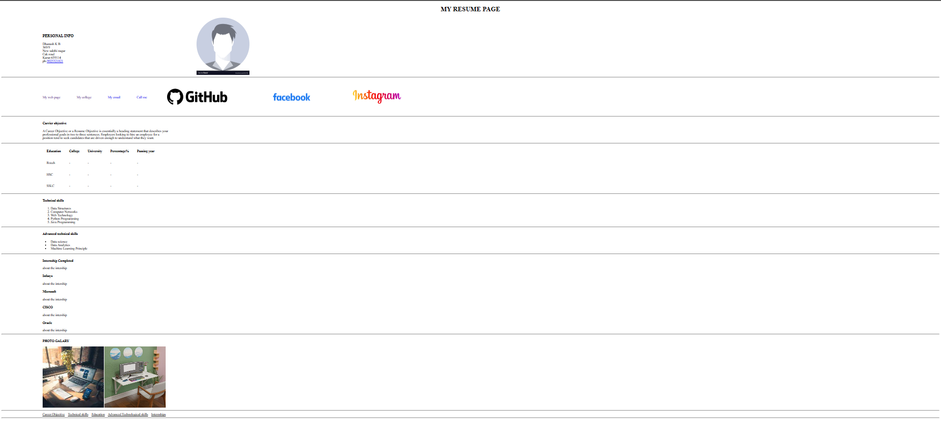

**Result**

The resume website is built successfully using the HTML.